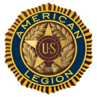 THE AMERICAN LEGION Clinton McCausland Post No. 190
P.O. Box 522 Ripon, CA 95366
(209) 924-4419

January 10, 2020
Dear Valued Community Partner,
The Clinton McCausland American Legion Post #190 has served our area veterans for over 90 years by providing services for the increasing needs and challenges facing our military veterans. This spring, in partnership with the Auxiliary Unit #190, Sons of the American Squadron #190, and VetLife, we’re aiming to raise money to fund projects and programs; Veterans Affairs and Rehabilitation, Veteran’s Emergency Assistance Fund, Veteran Service Program, the Military Mile Banner Program, and Service Officer Program, along with other events and programs that we sponsor within our community.
On April 18, we are planning to host our 2nd Annual Amber Waves of Grain Brewfest fundraising event. The event will have commercial and home brewed beers and cider, appetizers, and music. Money will be raised through ticket sales and raffles at the event.
However, we think our efforts would go even farther with you as an official sponsor.
In this role, your business would provide a donation at one of our donation levels, and in turn we would promote your company as an event official sponsor. These donation levels are: Silver ($50), Gold ($100), and Platinum ($250). At the Gold and Platinum levels your business will also receive event tickets.
With your generous participation we can do so much more for our veterans, their families and our greater community. A successful fundraising campaign will allow us to expand our direct support to more veterans, and their families than ever before.
If you are interested in being our official event sponsor, please reach out to us at (209) 924-4419 or adjutant@americanlegionripon190.org.
Sincerely,
Ed Ormonde
Ed Ormonde
Post Commander

Sponsor Form on Reverse Side

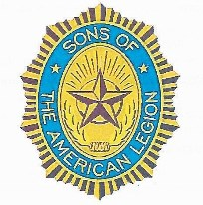
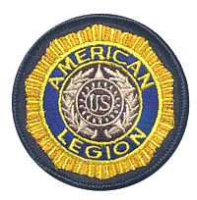
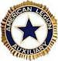

AMERICAN LEGION POST 190
Amber Waves Of Grain Brewfest
Saturday, April 18, 2020

EVENT SPONSOR FORM

______________________________will participate at the following
Company Name

Sponsor Level: Platinum $__________ Gold $__________ Silver $___________

Brewfest Representative _____________________________ Date: _________

Company Representative _____________________________ Date: _________

SPONSORSHIP OPPORTUNITIES

Platinum Sponsor - $250
● color advertisement on the inside cover of event program
● Prominent display in ‘Thank You’ advertisement on post website
● Sponsor recognition on all Social Media postings
● 3 event admission tickets to the Brewfest (Value - $120)

Gold Sponsor - $100
● color advertisement on the inside cover of event program
● prominent display in ‘Thank You’ advertisement on post website
● Sponsor recognition on all Social Media postings
● 2 event admission tickets to the Brewfest (Value - $80)

Silver Sponsor - $50
● Business Card advertisement on the back page of event program
● Sponsor recognition on all Social Media postings
Submission of business logos must be received by Post 190 (P.O. Box 522, Ripon, CA 95366) no later than March 10, 2020.
Clinton McCausland American Legion Post 190 is a 501(c)(19) Veteran Service Organization (Tax ID #94-6104854)

